



Elevation System
Documentation
Student name | Le Hong Phuong  Le Manh Toan  Nguyen Thanh Tung
Enrollment No. | Student463258, Student613041, Student615842
Group | 6
Semester | 2
Teacher | Nguyen Viet Khoa

INTRO
With the demand for the use and installation of the elevator market is growing today. So handy for customers to want to use and install elevators, our team has built around management program ... with modern features, ordering....

Contents
I. Problem Definition 4
1. Problem Abstraction 4
2. The Current System 4
3. The Proposed System 4
4. Boundaries of the System 4
5. Hardware and Software Requirements 4
a. Minimum Requirements 4
b. Recommended Requirements 5
c. Software 5
II. Customer Requirements Specification 5
1. Employee of the System 5
2. System functions 5
a. Add, edit Elevator 5
b. Display information detail elevator 6
a. Search Elevator 6
b. Order Elevator 6
III. Architecture & Design of Project 7
1. Elevation’s ERD 7
2. Data Flow Diagram 7
3. Entity Relationship Diagram (Table Design) 9
4. Database Structure 9
a. User Details: 9
b. Order Details: 9
c. Maintenance Details: 10
d. Employee Details: 10
e. Elevator Details: 10
f. Complaints Details 11
g. Clients Details: 11
h. Bill Details: 11
5. Screen Design 12

I. Problem Definition

1. Problem Abstraction
Today, business manages system to require the effect and to economize time. First and foremost in business management elevation of a company. Therefore we present software to manage elevator of the D’Hellas’s company.

2. The Current System
D’Hellas is a France company and was founded on 1987, based on the know-how and license of one of the biggest lift companies. The company concerns manufacturing, trading and maintenance of the complete lift system. It is enlisted among the largest companies in the world. Millions of people in the whole world recognize and rely on D’Hellas.

3. The Proposed System
The company already have website but need an Desktop Application for the internal working of the data within the organization to ensure that the services is provided or not. Apart from manufacturing the lift system and providing the client (“Firm”, “Organization”) and so on it must also take care of maintaining the system. Hence regularly checkup of all the installed system is done by the organization.

4. Boundaries of the System
Boundaries of system will built:
- We need an Elevation System Software, small in size, but easy to use, just only for us.

5. Hardware and Software Requirements

a. Minimum Requirements

Minimum
PC Pentium II 600 MHz
128MB RAM
500 MB hard drive

b. Recommended Requirements
Preferred
PC Pentium III 1800 MHz
2G RAM
2 GB hard drive

c. Software
- JDK 7.x
- Netbeans 7.x
- SQL Server 2008
- Notepad++

II. Customer Requirements Specification

1. Employee of the System
The objects influence system include:
- Admin
- Employee

2. System functions
Function Admin

a. Add, edit Elevator
Description | Admin add, edit elevator.
Input | -Name.  -Type  -Warranty  -Price  -Weight limit  -Speed  -Made in  -Image
Process | Update data in database when add, edit elevator.
Output | Display elevator edit and elevator new.

b. Display information detail elevator
Description | See the elevator details.
Input | - Chose the elevator.
Process | To take the information book from database
Output | - Display the information require

Function Employee

a. Search Elevator
Description | Employee search elevator
Input | - Name  - Type  - Price  - Speed  - Weight  - Warranty  - Made in
Process | Access data from database and to take elevator’s information satisfy require search.
Output | -If elevator available then display elevator’s information book where Employee search.  -If elevator doesn’t exist then won’t display

b. Order Elevator
Description | Employee agree to buy elevator(s)
Input | - Client’s name  - Complete Date
Process
Output

III. Architecture & Design of Project

1. Elevation’s ERD

Add
View

Elevator
Admin
Employee
-Name
-Type
-Warranty
-Price
-Weight limit
-Speed
-Made in
-Image

Edit
Order

2. Data Flow Diagram

View

Admin
Elevator
Add

Edit

View

Elevator
Employee
Search
Order

3. Entity Relationship Diagram (Table Design)
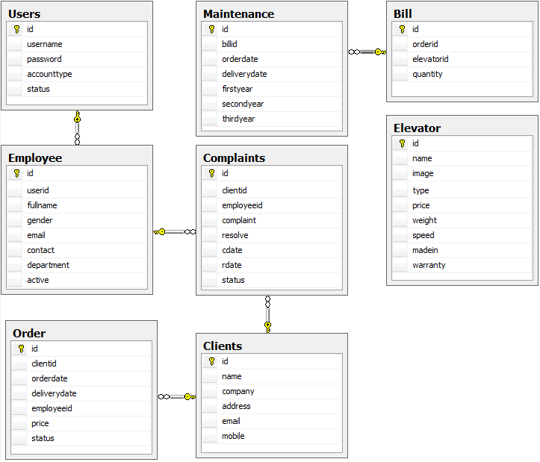

4. Database Structure

a. User Details:
FieldName | DataType | Contrain
id | Int | Not null
username | Nvarchar(255) | Null
password | Nvarchar(255) | Null
accounttype | Int | Null
status | Int | Null

b. Order Details:
FieldName | DataType | Contrain
id | Int | Not null
clientid | Int | Not null
orderdate | Nvarchar(255) | Not null
deliverydate | Nvarchar(255) | Null
employeeid | Int | Null
price | Float | Not null
status | Int | Null

c. Maintenance Details:
FieldName | DataType | Contrain
id | Int | Not null
clientid | Int | Null
employeeid | Int | Null
elevatorid | Int | Null
status | Int | Null

d. Employee Details:
FieldName | DataType | Contrain
id | Int | Not null
userid | Int | Null
fullname | Nvarchar(255) | Null
gender | Int | Null
email | Nvarchar(255) | Null
contact | Nvarchar(255) | Null
department | Int | Null
active | Int | Nul

e. Elevator Details:
FieldName | DataType | Contrain
id | Int | Not null
name | Nvarchar(255) | Null
image | Nvarchar(255) | Null
type | Nvarchar(255) | Null
price | Float | Null
weight | Float | Null
speed | Float | Null
madein | Nvarchar(255) | Null
warranty | Int | Null

f. Complaints Details
FieldName | DataType | Contrain
id | Int | Not null
clientid | Int | Null
employeeid | Int | Null
complaint | Text | Null
resolve | Text | Null
cdate | Varchar(255) | Null
rdate | Varchar(255) | Null
status | Int | Null

g. Clients Details:
FieldName | DataType | Contrain
id | Int | Not null
name | Nvarchar(255) | Null
company | Nvarchar(255) | Null
address | Nvarchar(255) | Null
email | Nvarchar(255) | Null
mobile | Nvarchar(255) | Null

h. Bill Details:
FieldName | DataType | Contrain
id | Int | Not null
orderid | Int | Not null
elevatorid | Int | Not null
quantity | Int | Not null

5. Screen Design

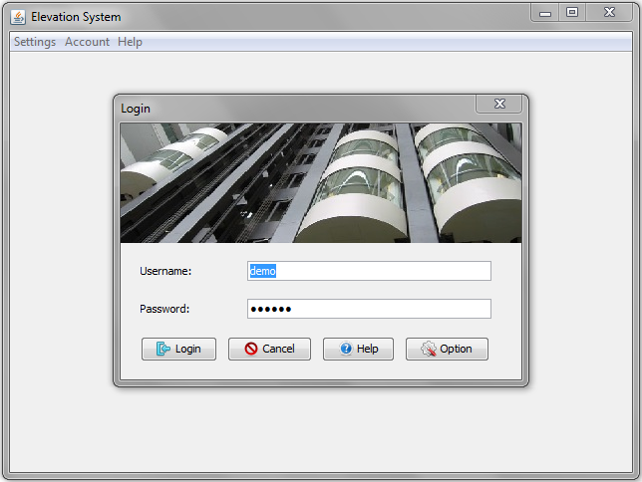
Figure 1: Login
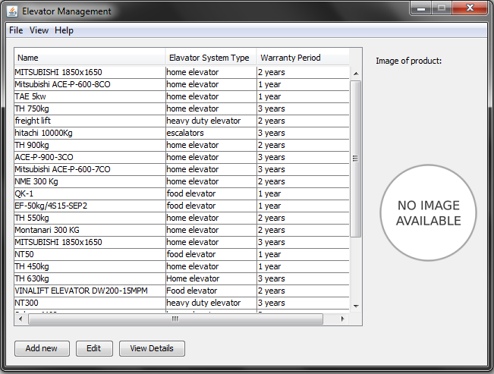
Figure 2: Admin main
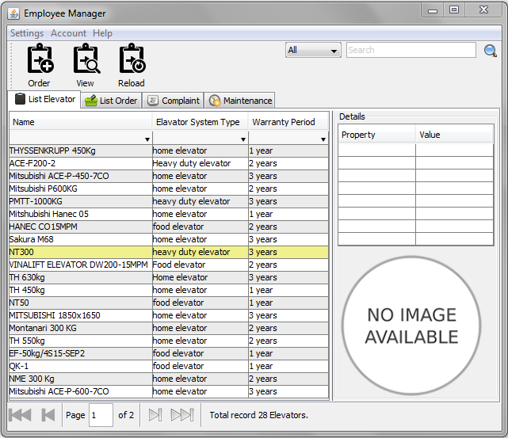
Figure 3: Employee main

IV. TASK SHEET

SR. No. | Task | Date of Preparation of Activity Plan: 11/02/2013
SR. No. | Task | Start Date | Finish Date | Team Member Names | Status
Document
1 | Problem Definition | 11/02/2013 | 11/03/2013 | Le Manh Toan  Nguyen Thanh Tung | Completed
2 | Customer Requirements Specification | 11/02/2013 | 11/04/2013 | Nguyen Thanh Tung | Completed
3 | DFD  ERD | 11/02/2013 | 11/25/2013 | Nguyen Thanh Tung  Le Hong Phuong | Completed
4 | Table Design | 11/02/2013 | 11/25/2013 | Le Manh Toan  Le Hong Phuong | Completed
5 | Mocks UI | 11/02/2013 | 11/25/2013 | Nguyen Thanh Tung | Completed
Code
1 | Login  Logout  Database Config | 11/04/2013 | 11/04/2013 | Le Hong Phuong | Completed
2 | Menu:  + Help  + Account  + Settings | 11/05/2013 | 11/07/2013 | Nguyen Thanh Tung | Completed
3 | Employee Manager | 11/05/2013 | 11/27/2013 | Le Manh Toan | Completed
4 | Admin Manager | 11/07/2013 | 11/27/2013 | Le Manh Toan | Completed
5 | Elevator Manager | 11/05/2013 | 11/11/2013 | Le Hong Phuong  Le Manh Toan | Completed
6 | Order Manager | 11/08/2013 | 11/19/2013 | Le Hong Phuong  Le Manh Toan | Completed
7 | Complaint Manager | 11/24/2013 | 11/28/2013 | Nguyen Thanh Tung  Le Hong Phuong | Completed
8 | Maintenance Manager | 11/24/2013 | 11/28/2013 | Nguyen Thanh Tung  Le Hong Phuong | Completed
9 | Paging | 11/05/2013 | 11/07/2013 | Le Hong Phuong | Completed
10 | Search | 11/06/2013 | 11/17/2013 | Le Hong Phuong  Le Manh Toan | Completed
11 | Client Manager | 11/09/2013 | 11/27/2013 | Le Hong Phuong  Le Manh Toan | Completed
12 | Statistic | 11/19/2013 | 11/22/2013 | Le Manh Toan | Completed
13 | User Manager | 11/22/2013 | 11/23/2013 | Le Hong Phuong | Completed
14 | Refactoring | 11/26/2013 | 11/28/2013 | Le Hong Phuong  Le Manh Toan | Completed

PRACTICE RESULTS
* Content knowledge strengthened:
Over time we also try to practice a lot of knowledge of java programming that we learned at school and apply it in practice.

* Practical Skills trained:
We have accumulated a lot of knowledge over time this practice. Through the work assigned, we understand how to create an elevation system management, the ability to read the English language is enhanced. Knowledge is increasingly strengthened and perfected.

* Practical experience has accumulated:
Through this internship we learned a lot of practical experience for us and we noticed that through self-study materials, English websites, forums exchanged very beneficial.

*****
And finally we would like to express our sincere thanks and deep gratitude to the teachers of the FPT University, especially to Mr. Khoa has created the conditions for us to practice in science and have more time for the project.
During the internship, as well as in the report process, unavoidable errors, we hope you can forgive us. At the same time due to the theoretical as well as practical experience is limited to all reports inevitable shortcomings, we look forward to receiving comments to complete our report upcoming graduation.
We sincerely thank you!

